**CEA Request Submission**

1. **Project Inquiry** – this web form contains the list of all projects allocated for a specific cost center based on fiscal year. Data in the grid is fetch from the Projects transactional table stored in SQL Server.

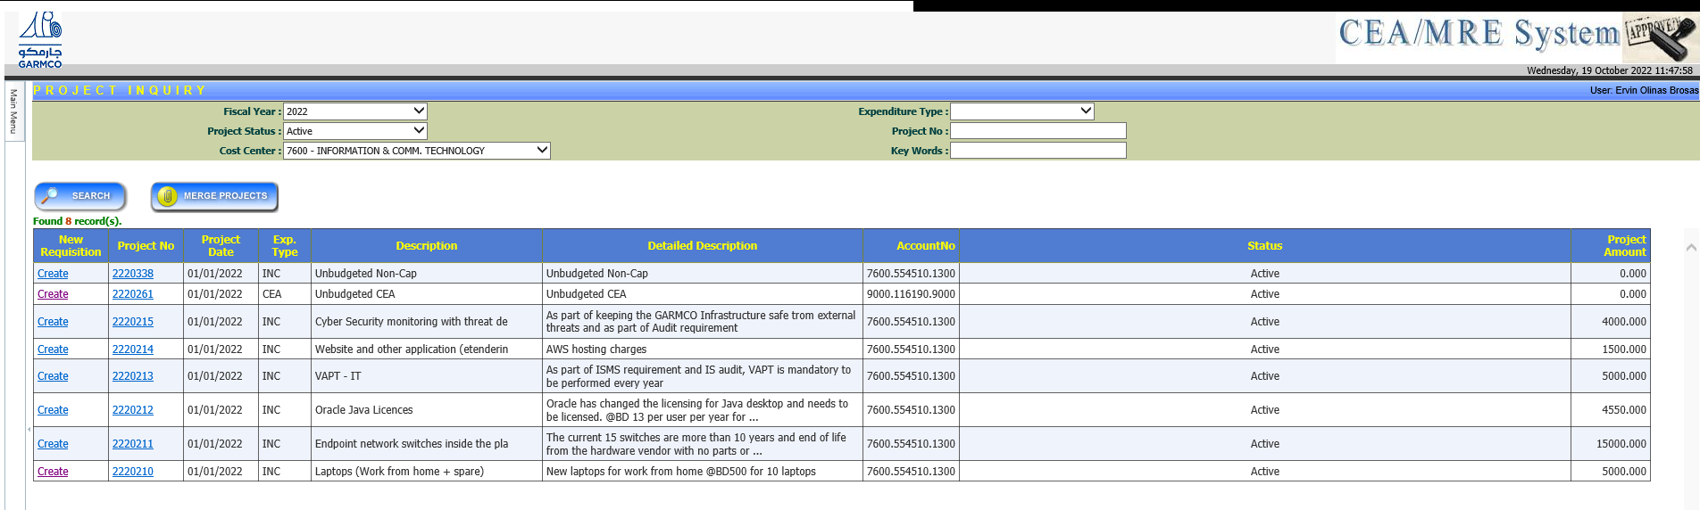

1. **CEA Requisition** – this is the data entry form for submitting a CEA request. The required fields

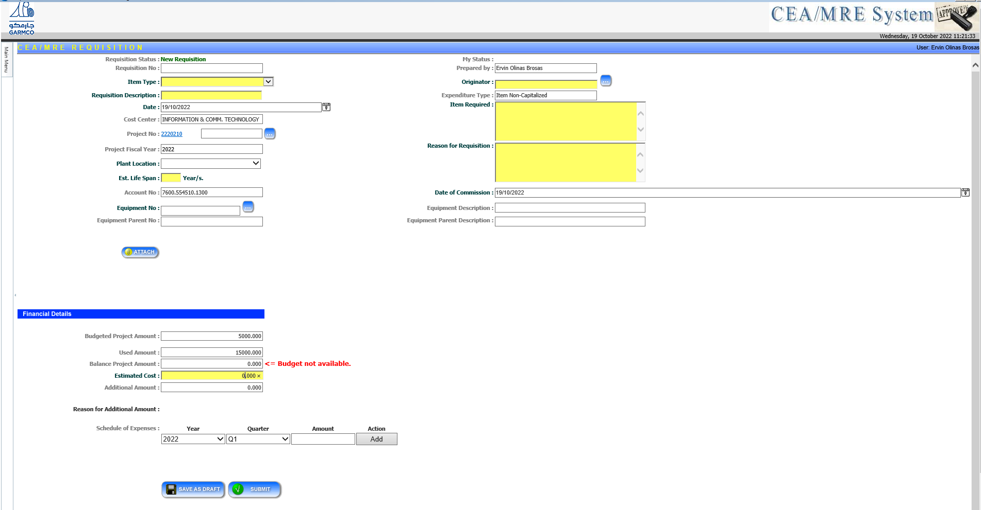

The “**Originator**” field refers to the employee who will validate the request once submitted. It should fetch data from our JDE ERP system wherein the backend database is SQL Server. This field should contain a smart textbox wherein the user enters the employee number (using the following format: 1000xxxx ex. 10003632) which results to the employee full name being shown in the datalist. Also, a button beside this field will enable the user to search and find the desired employee. A pop-up form will appear on the screen as shown in the screenshot below. Data can be filtered by cost center, employee number, and employee name.

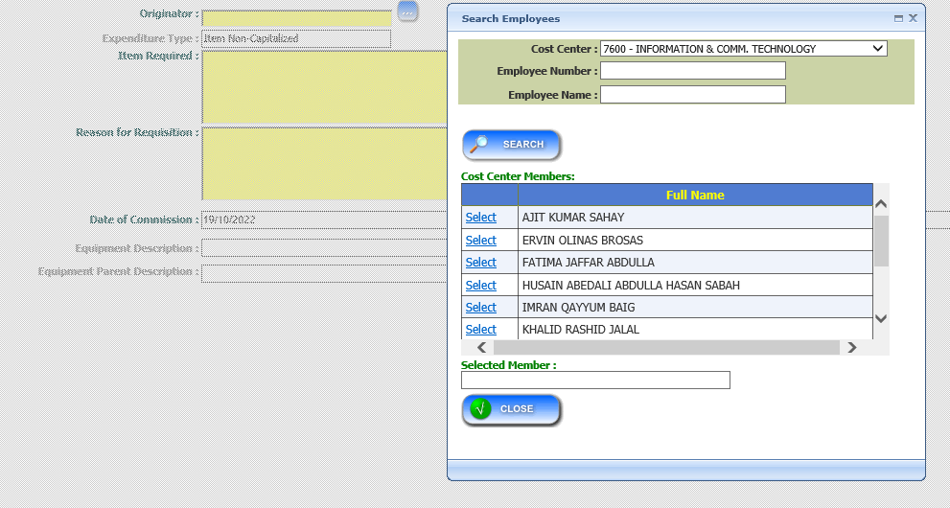

The “**Item Type**” field contains the predefined list which can be hardcoded in the system. It does not fetch data from an external ERP system.

